**ABSTRACT**

In times of rapidly expanding mega cities all around the world, traffic congestion and mobility are becoming a growing problem. Only too familiar are the pictures of crowded highways packed with cabs, bikes, and cars, where nothing is moving due to constant traffic jams. Hence making traffic flows more efficient will be of greater importance with each passing day. By controlling the traffic, both travel time and negative impact on the environment can be reduced. However, efficient control requires cost-efficient and accurate estimation of traffic parameters, such as the number of vehicles passing a certain point per unit time, the current speed of vehicles, and their types.

The most popular methods of acquiring traffic parameters that are currently used in India, i.e. video image processing and infrared sensors, suffer from several drawbacks such as dependence on clear environmental conditions and suitable ambient light requirements.

The objective of the project is to develop a traffic monitoring and classification system using low power, low cost magnetic sensors and induction loops that are free from the aforementioned drawbacks.

The magnetic materials in a vehicle change the ambient magnetic field when the vehicle passes over the magnetic field sensors. This change is used to detect the vehicles moving over the sensor. The amount of change in magnetic field depends on the volume of the magnetic materials in the vehicle. Since two wheelers have comparatively lesser volume of magnetic materials, they produce smaller changes in the magnetic field compared to four wheelers. This difference is used for classification of the vehicles. The data acquired from this system is used to increase the efficiency of the existing roadways and to enhance the capacity of transportation networks at locations where the traffic densities are large.

**Keywords**

Traffic Monitoring, iSense core, Gateway and Vehicle detection modules, Induction loops, Wireless sensor networks, ZigBee communication, Colpitt’s oscillator, Arduino 2560.

**ACKNOWLEDGEMENT**

First of all, we thank the almighty for providing us the strength and courage to complete the project in spite of the innumerable hurdles we faced.

We take this opportunity to express our profound gratitude to **Dr. M. S. Suresh, Principal, Prof. T. J. Rama Murthy, Director, BNMIT** for their continuous effort in creating a competitive environment in our college and encouragement through this course. We are also indebted to **Dr. S. B.** **Bhanu Prashanth, HOD, Department of Electronics and Communication Engineering, BNMIT**, for his valuable guidance and support.

We wholeheartedly thank our project supervisor, **Prof. Anuradha V. Rao**, **Department of Electronics and Communication Engineering, BNM Institute of Technology**, for continuously encouraging us to put in our best efforts. Her suggestion to improve the project is priceless and the support lent during trying times is fully appreciated.

We express sincere gratitude to our external guide **Mr. Ravikumar D, Deputy General Manager, Project and Consultancy Department** and **Mr. Surendra Kumar**, **Mr. Sourav Sarkar, Senior Engineers, Project and Consultancy Departmen**t, at **Bharat Electronics Limited, Bangalore** for assigning the project and spending their valuable time in guiding us.

We also thank all the teaching and non teaching staff of BNMIT for their inspiration and for guiding us through the right paths.

Last but not the least, this project would not have been complete without the support, guidance and coordination of our parents and friends.

**Project Associates:**

Pradeep Kumar. N 1BG10EC058

Nikunj Tonthanahal 1BG10EC054

Nafeeya Samar 1BG10EC047

Noor Zahara 1BG10EC055

**TABLE OF CONTENTS**

I. INTRODUCTION 1

1.1 Motivation 1

1.2 Overview 1

1.1.1 Induction loop vehicle detection system 2

1.1.2 Anisotropic Magneto-Resistive vehicle detection system 4

II. DESIGN 9

2.1 General description 9

2.2 Hardware requirements 9

2.2.1 Inductive loops 9

2.2.2 Colpitt’s Oscillator 10

2.2.3 Comparator 11

2.2.4 Quad Op-Amp IC MC33274 11

2.2.5 Microcontroller: Arduino 2560 12

2.2.5 Voltage regulators: LM7805 and RT9164A 14

2.2.5.1 LM7805 14

2.2.5.1 RT9164A 15

2.2.6 Anisotropic Magneto Resistive sensors: KMZ52 16

2.2.7 Microcontroller with transceiver: Jennic JN5148-001 17

2.2.7.1 Wireless Transceiver 18

2.2.7.2 RISC CPU, On chip memory and Peripherals (Microcontroller) 22

2.3 Software requirements 24

2.3.1 LTspice IV 24

2.3.1.1 Simulating circuits using LTspice IV 25

2.3.2 Arduino IDE 28

2.3.2.1 Using the Arduino integrated development environment (IDE) to program 28

2.3.3 Cygwin 30

2.3.3.1 Description 30

2.3.5 iShell 31

2.3.6 Eclipse Indigo 35

2.3.6.1 Description 35

2.3.7 Microsoft Visual Studio 12.0 38

2.5 Design of AMR sensor vehicle detection system 46

III. RESULTS 51

3.1 Induction loop vehicle detection system 51

3.2 AMR sensor vehicle detection system 53

IV. CONCLUSION 54

V. FUTURE ENHANCEMENTS 55

VI. REFERENCES 56

# I. INTRODUCTION

## 1.1 Motivation

Traffic congestion and associated effects such as air pollution pose major concerns to the public. Congestion has increased dramatically during the past 20 years in all the major Indian cities. Congestion is an outcome of twin factors, (a) growth in number of vehicles on road, (b) limitations to expansion of road space. While the road length in urban areas was only 7 per cent of the total road length in India, in 2002, the number of registered motor vehicles in the 23 largest cities alone was 30 per cent of the total registered motor vehicles in the country. Thus, urban congestion is a serious problem and has severely constrained mobility.

Traffic congestion may be alleviated by improving the efficiency of the current transportation system through the implementation of advanced technologies. Real-time traffic surveillance is one of the most important components of such an approach, and real-time travel information is useful for advanced travel advisory systems. Emergency management agencies such as police, fire stations, and ambulance dispatchers may also benefit from real-time traffic information in routing their vehicles through the transportation network to save lives. Roadway safety and efficiency will be significantly enhanced by employing remote sensing and communication technologies capable of providing low-cost, scalable, and distributed data acquisition of road conditions. Such Intelligent Transportation System (ITS) applications require distributed acquisition of different traffic metrics such as traffic speed, volume, and density which can be obtained using magnetic sensors and induction loops.

## 1.2 Overview

In times of rapidly expanding mega cities all around the world, traffic congestion and mobility are becoming a growing problem. Maximizing the efficiency and capacity of existing transportation networks is vital because of the continued increase in traffic volume and the limited construction of new highway facilities in urban, inter-city, and rural areas. Even when additional facilities are built to ease congestion and promote the use of multiple occupancy vehicles, the cost is often quite high. An alternative to expensive new highway construction is the implementation of strategies that promote more efficient utilization of current road, rail, air, and water transportation facilities. Efficient control requires cost-efficient and accurate estimation of traffic parameters, such as the number of vehicles passing a certain point per unit time, the current speed of vehicles, and their types. The estimation can be based on data collected from magnetic sensors placed close to the road or induction loops buried into the road surface.

A vehicle is built up of several types of magnetic materials; soft magnetic materials with no residual magnetization and hard magnetic materials with high residual magnetization. All of these materials in the vehicle create a disturbance in the earth magnetic field when the vehicle passes a specific region. When a magnetic sensor system with high field sensitivity and resolution, or a simple induction loop in placed in this region, it is possible to detect this change and hence the presence of vehicle. A generic block diagram of such a simple vehicle detection and monitoring system is shown in Fig 1.1.

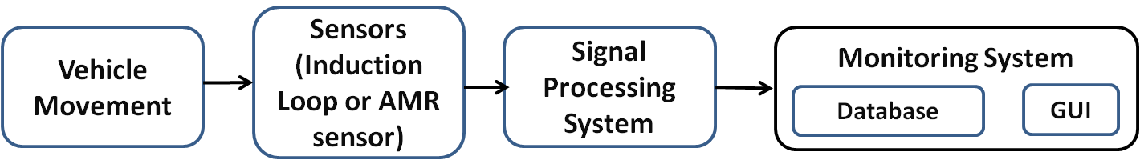

Fig 1.1 Block diagram of simple vehicle detection and monitoring system

The signal processing system processes the data from the sensors to eliminate any errors or false detections. Finally the traffic parameters acquired from the sensors are updated in a database and displayed using a GUI on the computer.

This project implements the induction loop as a means of acquiring vehicle count and classifying vehicles into two wheelers and four wheelers. The AMR sensors are used to acquire the count and speed of the vehicles.

### 1.1.1 Induction loop vehicle detection system

An induction loop is an insulated electric wire through which an alternating current is driven to set up an electromagnetic field which is disturbed when a vehicle passes over the loop. This disturbance is used to detect the presence of vehicles.

Since its introduction, the inductive-loop detector has become the most utilized sensor in a traffic management system. The principal components of an inductive-loop detector system include:

• One or more turns of insulated loop wire wound in a shallow slot sawed in the pavement.

• Lead-in cable from the loop to the controller cabinet.

• Electronics unit housed in a nearby controller cabinet.

Figure 1.2 displays a notional diagram of an inductive-loop detector.

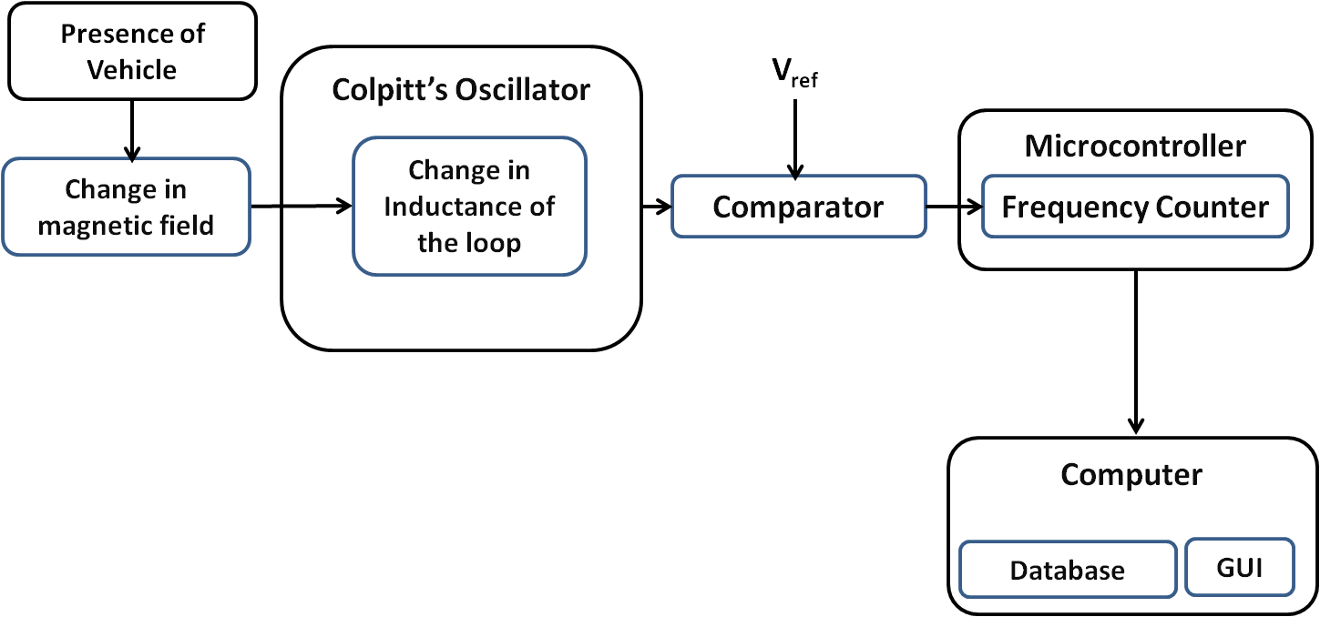

Fig 1.2 Block Diagram of Induction Loop Detector

The functioning of Inductive loop sensors is as follows. The inductive-loop is a part of the tank circuit of a Colpitt’s oscillator in which the loop wire and lead-in cable are the inductive elements. The comparator acts as an A/D convertor and converts the analog output signal of the oscillator into a square wave. This is fed to a microcontroller which continuously measures the frequency of the square wave input. When a vehicle passes over the loop or is stopped within the loop, the vehicle induces eddy currents in the wire loops, which decrease their inductance. The decreased inductance results in an increase in the frequency of the oscillator output. This increase in frequency is used by the microcontroller to detect the presence of vehicles.

The amount of eddy currents induced in the loop and thus the change in frequency depends on the mass of the ferromagnetic material in the proximity of the loop. Since two wheelers and four wheelers have different amounts of ferromagnetic material in them, the corresponding frequency change as they pass over the loop is also different. This difference is used by the microcontroller to classify the vehicles.

The traffic parameters i.e. the count and classification of vehicles is then sent by the microcontroller to a computer where they are displayed in the GUI and stored in a database. A flow chart for the functioning of the Induction loop detector system is shown in Fig 1.3.

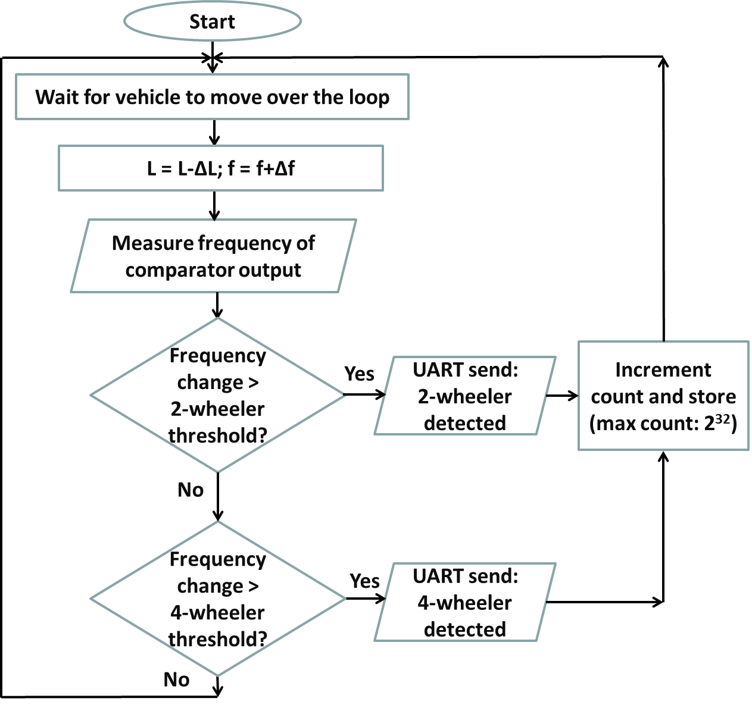

Fig 1.3 Flowchart for Induction Loop system

### 1.1.2 Anisotropic Magneto-Resistive vehicle detection system

An AMR sensor is a sensing device that utilizes the rate of change of magnetic resistance which is affected by the strength of the external magnetic field to detect the presence of vehicles.

Magnetic sensors were introduced as an alternative to the inductive-loop detector for specific applications. A magnetic sensor is designed to detect the presence or passage of a vehicle by measuring the perturbation in the Earth’s quiescent magnetic field caused by a ferrous metal object (e.g., a vehicle) when it enters the detection zone of the sensor.

Early magnetic sensors were utilized to determine if a vehicle had arrived at a “point” or small-area location. Modern AMR sensors are used for vehicle presence detection and counting. Unlike the inductive-loop detector, the magnetometer are usually used in places where cutting the deck pavement for loop installation is not permitted. Also, the magnetometer probe and its lead-in wire tend to survive in crumbly pavements longer than ordinary loops.

An iron or steel vehicle distorts the magnetic flux lines because ferrous materials are more permeable to magnetic flux than air. That is, the flux lines prefer to pass through the ferrous vehicle. As the vehicle moves along, it is always accompanied by a concentration of flux lines known as its “magnetic shadow” as illustrated in Fig 1.4. There is reduced flux to the sides of the vehicle and increased flux above and below it. An AMR sensor installed within the pavement detects the increased flux below the vehicle.

The block diagram of the AMR vehicle detection system is show in Fig 1.5. The system contains two slave modules that are buried along the length of the road with a distance of two meters between them. The slave modules consist of a two axis AMR sensor and a microcontroller interfaced with a ZigBee transceiver. The modules are used for speed calculation and communicate with a master module using ZigBee protocol. The master module consists of a microcontroller interfaced with a ZigBee transceiver and is connected to the computer through UART. The sensors on the slave modules detect the presence of vehicles and send a time stamp indicating the time at which the vehicle was detected to the master module. The difference in time indicated by the two time stamps is then used by the master module to calculate the speed using the following relation.

S = D/T............... (1.1)

where,

S is the speed,

D is the distance between the two AMR sensors i.e. 2m,

T is the difference between the times indicated by the two time stamps.

The traffic parameters i.e. the count and speed of the vehicles is then sent by the microcontroller to a computer where they are displayed in the GUI and stored in a database.



Fig 1.4 Distortion of Earth’s quiescent magnetic field by a ferrous metal vehicle

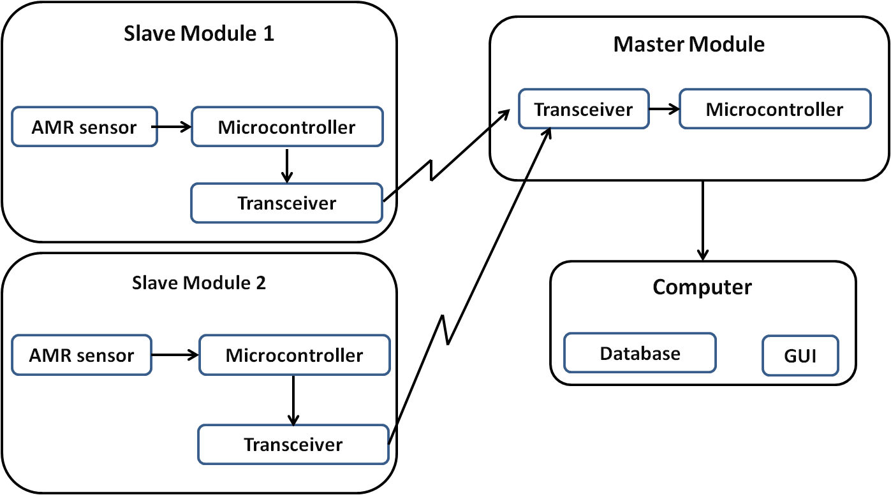

Fig 1.5 Block Diagram of AMR sensor Vehicle Detection System

A flow chart for the functioning of the slave and master modules is shown in Fig 1.6 and 1.7 respectively.

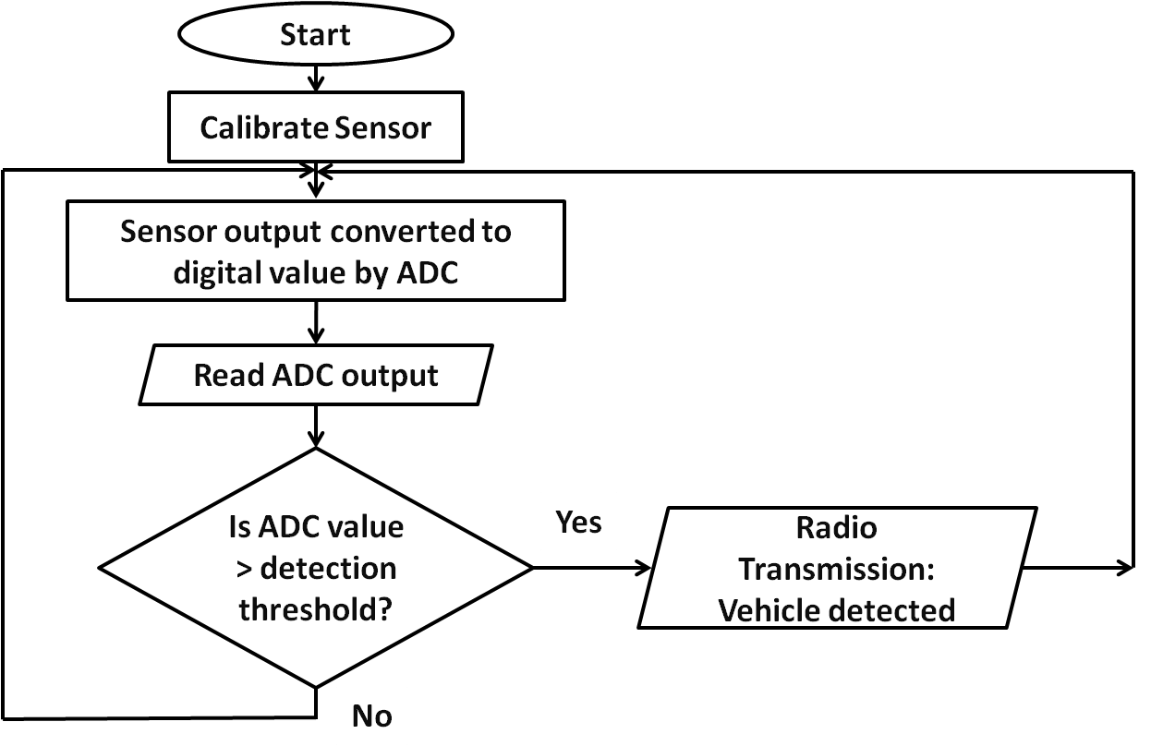

Fig 1.6 Flowchart for Slave Module

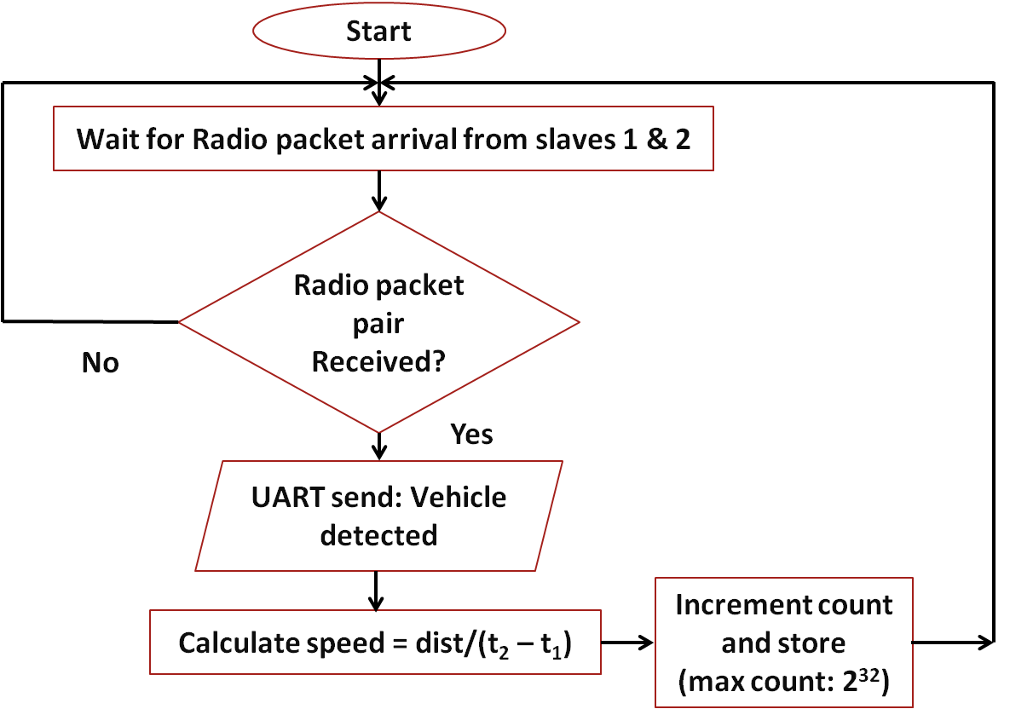

Fig 1.7 Flowchart for Master Module

# II. DESIGN

## 2.1 General description

This project involves various hardware components such as iSense core, gateway and vehicle detection modules, Inductive loops, Colpitt’s oscillator, Jennic and Arduino 2560 microcontrollers. The Eclipse IDE and Arduino software are used to program the Jennic microcontroller and Microsoft Visual Studio is used to develop the GUI. The project uses the concepts of embedded systems, measurements, sensors and wireless communication networks. This chapter highlights the details of each of the above topics.

## 2.2 Hardware requirements

* **Induction loop detection system**

1. Induction loop
2. Colpitt’s oscillator
3. Comparator
4. Quad Op-Amp IC MC33274
5. Microcontroller: Arduino 2560
6. 9V battery
7. Voltage regulators: LM7805 and RT9164A

### 2.2.1 Inductive loops

Inductive-loop wire, lead-in wires, and lead-in cables typically use #12, #14, or #16 American Wire Gauge (AWG) wire. Here a #12 AWG wire is used. The loop in the roadway also contains an induced resistance (called the ground resistance) caused by transformer coupling between the loop and induced currents flowing in the roadway and sub grade materials.

A roadway inductive loop has a non-uniform flux field that produces an inductance value given by

$L=\frac{μ_{r}μ_{0}N^{2}AF^{'}}{l}$............. (2.1)

where,

*r* = Relative permeability of material (1 for air)  
*0* = 4 x 10-7 henrys per meter.

*L* = Inductance, henrys  
*N* = Number of turns  
*I* = Coil current, amperes.

*A* = Cross sectional area of coil, m2

F' = a factor to account for the non uniform flux in the roadway inductive loop

### 2.2.2 Colpitt’s Oscillator

Oscillators are circuits that generate a continuous voltage output waveform at a required frequency with the values of the inductors, capacitors or resistors forming a frequency selective LC resonant tank circuit and feedback network. The frequency of the oscillatory voltage depends upon the value of the inductance and capacitance in the LC tank circuit. Then the frequency at which this will happen is given as:

XL = 2π*f*L.......... (2.2)

Xc = .......... (2.3)

At resonance: XL = XC

Equating 2.2 and 2.3,

∴ *2𝜋fL* = *f2*=

Therefore the resonance frequency of an LC oscillator is

*f* = $\frac{1}{2π \sqrt{LC}}$.......... (2.4)

Where:

L is the Inductance in Henry

C is the Capacitance in Farad

fr is the Output Frequency in Hertz

Equation 2.4 shows that if either L or C is decreased, the frequency increases. This output frequency is commonly given the abbreviation of (fr) to identify it as the “resonant frequency”.

The Colpitt’s oscillator of the induction loop detection system utilizes MC33274, a quad op-amp IC and oscillates at a resonant frequency of 50 KHz. The oscillator makes use of an inductive loop of 100µH and effective capacitance of 0.22µF. The output of the oscillator is fed to a comparator which produces square waves of the same frequency as the oscillations, ready to be fed to the microcontroller.

### 2.2.3 Comparator

The comparator is also implemented using the Quad op-amp IC MC33274 and operates with a reference voltage of 2.5V. It essentially acts as an A/D convertor and converts the input sine wave into a square wave at the output which is then fed to the microcontroller for frequency measurement.

### 2.2.4 Quad Op-Amp IC MC33274

The MC33274 is quad operational amplifier that incorporates Bipolar inputs along with a patented Zip−R−Trim element for input offset voltage reduction. The MC33274 series of operational amplifiers exhibits low input offset voltage and high gain bandwidth product.

Dual−doublet frequency compensation is used to increase the slew rate while maintaining low input noise characteristics. It’s all NPN output stage exhibits no dead band crossover distortion, large output voltage swing, and an excellent phase and gain margin. It also provides low open loop high frequency output impedance with symmetrical source and sink AC frequency performance.

The features of MC33274 are listed below.

• Input Offset Voltage Trimmed to 100µV (Typical)

• Low Input Bias Current: 300nA

• Low Input Offset Current: 3.0nA

• High Input Resistance: 16 MΩ

• Low Noise: 18 nV/ $\sqrt{ Hz}$@ 1.0 kHz

• High Gain Bandwidth Product: 24 MHz @ 100 kHz

• High Slew Rate: 10 V/µs

• Power Bandwidth: 160 kHz

• Excellent Frequency Stability

• Unity Gain Stable: w/Capacitance Loads to 500 pF

• Large Output Voltage Swing: +14.1 V/ −14.6 V

• Low Total Harmonic Distortion: 0.003%

• Power Supply Drain Current: 2.15 mA per Amplifier

• Single or Split Supply Operation: +3.0 V to +36 V or $±$ 1.5 V to $±$ 18 V

The pin diagram of MC33274 is as shown in Fig 2.1



Fig 2.1 Pin diagram of MC33274 (top view)

### 2.2.5 Microcontroller: Arduino 2560

The Arduino board uses a High Performance, Low Power Atmel® AVR® 8-Bit Microcontroller. The ATmega 2560 is a low-power CMOS 8-bit microcontroller based on the AVR enhanced RISC architecture. Some of the peripheral features of the Arduino include two 8-bit Timer/Counters with separate Prescaler and Compare Mode.

The microcontroller board is suitable for wide temperature ranges varying from -40°C to 85°C.

It also includes properties of Ultra-Low Power Consumption with two different modes of operation:

– Active Mode: 1MHz, 1.8V: 500μA

– Power-down Mode: 0.1μA at 1.8V

It also has High Endurance Non-volatile Memory Segments

– 256KBytes of In-System Self-Programmable Flash

– 4Kbytes EEPROM

– 8Kbytes Internal SRAM

– Write/Erase Cycles:10,000 Flash/100,000 EEPROM

– Data retention: 20 years at 85°C/ 100 years at 25°C

This microcontroller is programmed to calculate the frequency of the signal fed at one of its I/O pins. The deviation of frequency from the central frequency of the oscillator determines that a vehicle is present in the inductive loop. This helps in vehicle detection.

The block diagram of ATmega 2560 is shown in Fig 2.2.



Fig 2.2 Block diagram of ATmega 2560

### 2.2.5 Voltage regulators: LM7805 and RT9164A

#### 2.2.5.1 LM7805

The LM7805 is a three-terminal positive 5V regulator. This regulator can provide local on-card regulation, eliminating the distribution problems associated with single point regulation. It employs internal current limiting, thermal shut-down and safe area protection, making it essentially indestructible. If adequate heat sinking is provided, it can deliver over 1A output current. Although designed primarily as a fixed voltage regulator, it can be used with external components to obtain adjustable voltage and currents.

Fig 2.3 shows the pin configuration of LM7805.

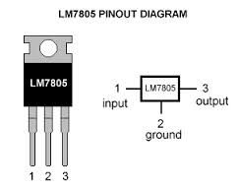

Fig 2.3 Pin configuration of LM7805

Here LM7805 is used to obtain a fixed 5V supply that is connected to the Vcc pin of op-amp MC33274.

The block diagram of LM7805 is shown in Fig 2.4



Fig 2.4 Block diagram of LM7805

#### 2.2.5.1 RT9164A

The RT9164A is a high performance positive voltage regulators designed for applications requiring low dropout performance at fully rated current. Additionally, the RT9164A provides excellent regulation over variations in line and load. Outstanding features include low dropout performance at rated current, fast transient response, internal current-limiting and thermal-shutdown protection of the output device.

The pin configuration of RT9164A is shown in Fig 2.5



Fig 2.5 Pin configuration of RT9164A

**Features of RT9164A:**

1. Low Dropout Performance, 1.4V Max
2. Full Current Rating Over Line and Temperature
3. Fast Transient Response
4. ±2% Output Voltage Accuracy
5. 1.5V, 1.8V, 2.5V, 2.85V, 3.0V, 3.3V, and 3.5V Fixed
6. Adjustable Output Voltage

The functional block diagram of RT9164A is as shown in Fig 2.6

Fig 2.6 Functional block diagram of RT9164A

* **AMR sensor vehicle detection system**

1. Anisotropic Magneto Resistive sensors
2. Microcontroller with transceiver: Jennic JN5148-001
3. 1.5V batteries

### 2.2.6 Anisotropic Magneto Resistive sensors: KMZ52

The KMZ52 is an extremely sensitive magnetic field sensor, employing the magneto-resistive effect of thin-film Permalloy. The sensor contains two magneto-resistive Wheatstone bridges physically offset from one another by 90° and integrated compensation and set/reset coils. The integrated compensation coils allow magnetic field measurement with current feedback loops to generate outputs that are independent of drift in sensitivity. The orientation of sensitivity may be set or changed (flipped) by means of the integrated set/reset coils. A short current pulse should be applied to the compensation coils to recover (set) the sensor after exposure to strong disturbing magnetic fields. A negative current pulse will reset the sensor to reversed sensitivity. By use of periodically alternated flipping pulses and a lock-in amplifier, the output is made independent of sensor and amplifier offset.

The features of KMZ52 are listed below.

* High sensitivity
* Integrated compensation coil
* Integrated set/reset coil.

The simplified circuit diagram of KMZ52 is as shown in Fig 2.7



Fig 2.7 Simplified circuit diagram of KMZ52

### 2.2.7 Microcontroller with transceiver: Jennic JN5148-001

The JN5148-001 is an IEEE802.15.4 wireless microcontroller that provides a fully integrated solution for applications using the IEEE802.15.4 standard in the 2.4 - 2.5GHz ISM frequency band [1], including JenNet and ZigBee PRO. It includes all of the functionality required to meet the IEEE802.15.4, JenNet and ZigBee PRO specifications and has additional processor capability to run a wide range of applications including, but not limited to Smart Energy, Automatic Meter Reading, Remote Control, Home and Building Automation, Toys and Gaming.

Applications that transfer data wirelessly tend to be more complex than wired ones. Wireless protocols make stringent demands on frequencies, data formats, timing of data transfers, security and other issues. Application development must consider the requirements of the wireless network in addition to the product functionality and user interfaces. To minimise this complexity, NXP provides a series of software libraries and interfaces that control the transceiver and peripherals of the JN5148. These libraries and interfaces remove the need for the developer to understand wireless protocols and greatly simplifies the programming complexities of power modes, interrupts and hardware functionality.

A simple block diagram of JN5148-001 is as shown in Fig 2.8



Fig 2.8 Block diagram of JN5148-001

The device includes a Wireless Transceiver, RISC CPU, on chip memory and an extensive range of peripherals.

#### 2.2.7.1 Wireless Transceiver

The Wireless Transceiver comprises of

* 2.45GHz radio
* A modem
* A baseband controller

In addition, the radio also provides an output to control transmit-receive switching of external devices such as power amplifiers allowing applications that require increased transmit power to be realized very easily.

The transceiver elements (radio, modem and baseband) work together to provide IEEE802.15.4 Media Access Control (MAC) under the control of a protocol stack. Applications incorporating IEEE802.15.4 functionality can be rapidly developed by combining user-developed application software with a protocol stack library.

Features: Transceiver

• 2.4GHz IEEE802.15.4 compliant

• MAC accelerator with packet formatting, CRCs, address check, auto-acks, timers

• 500 & 667kbps data rate modes

• Integrated sleep oscillator for low power

• On chip power regulation for 2.0V to 3.6V battery operation

• Deep sleep current 100nA

• Sleep current with active sleep timer 1.25μA

• Rx current 17.5mA

• Tx current 15.0mA

• Receiver sensitivity -95dBm

• Transmit power 2.5dBm

**Radio**

Fig 2.9 shows the single ended radio architecture.

The radio comprises a low-IF receive path and a direct modulation transmit path, which converge at the TX/RX switch. The switch connects to the external single ended matching network, which consists of two inductors and a capacitor, this arrangement creates a 50Ω port and removes the need for a balun. A 50Ω single ended antenna can be connected directly to this port.

The 32MHz crystal oscillator feeds a divider, which provides the frequency synthesizer with a reference frequency. The synthesizer contains programmable feedback dividers, phase detector, charge pump and internal Voltage Controlled Oscillator (VCO). The VCO has no external components, and includes calibration circuitry to compensate for differences in internal component values due to process and temperature variations. The VCO is controlled by a Phase Locked Loop (PLL) that has an internal loop filter. A programmable charge pump is also used to tune the loop characteristic.



Fig 2.9 Radio Architecture

The receiver chain starts with the low noise amplifier / mixer combination whose outputs are passed to a lowpass filter, which provides the channel definition. The signal is then passed to a series of amplifier blocks forming a limiting strip. The signal is converted to a digital signal before being passed to the Modem. The gain control for the RX path is derived in the automatic gain control (AGC) block within the Modem, which samples the signal level at various points down the RX chain. To improve the performance and reduce current consumption, automatic calibration is applied to various blocks in the RX path.

In the transmit direction, the digital stream from the Modem is passed to a digital sigma-delta modulator which controls the feedback dividers in the synthesizer, (dual point modulation). The VCO frequency now tracks the applied modulation. The 2.4 GHz signal from the VCO is then passed to the RF Power Amplifier (PA), whose power control can be selected from one of three settings. The output of the PA drives the antenna via the RX/TX switch.

**Modem**

The modem performs all the necessary modulation and spreading functions required for digital transmission and reception of data at 250kbps in the 2450MHz radio frequency band in compliance with the IEEE802.15.4 standard. It also provides high data rate modes at 500 and 667kbps. The architecture of the modem is as shown in Fig 2.10



Fig 2.10 Modem Architecture

**Baseband Controller**



Fig 2.11 Baseband Controller

The baseband processor provides all time-critical functions of the IEEE802.15.4 MAC layer. Dedicated hardware guarantees air interface timing is precise. The MAC layer hardware/software partitioning, enables software to implement the sequencing of events required by the protocol and to schedule timed events with millisecond resolution, and the hardware to implement specific events with microsecond timing resolution. The protocol software layer performs the higher-layer aspects of the protocol, sending management and data messages between endpoint and coordinator nodes, using the services provided by the baseband processor. Fig 2.11 shows the block diagram of the baseband controller.

#### 2.2.7.2 RISC CPU, On chip memory and Peripherals (Microcontroller)

A 32-bit RISC CPU allows software to be run on chip, its processing power being shared between the IEEE802.15.4 MAC protocol, other higher layer protocols and the user application. The JN5148 has a unified memory architecture, code memory, data memory, peripheral devices and I/O ports are organized within the same linear address space. The device contains 128kbytes of ROM, 128kbytes of RAM and a 32-byte One Time Programmable (OTP) eFuse memory.

**Features: Microcontroller**

• Low power 32-bit RISC CPU, 4 to 32MHz clock speed

• Variable instruction width for high coding efficiency

• Multi-stage instruction pipeline

• 128kB ROM and 128kB RAM for bootloaded program code & data

• 4-input 12-bit ADC, 2 12-bit DACs, 2 comparators

• 3 application timer/counters,

• 2 UARTs

• SPI port with 5 selects

• 2-wire serial interface

• Watchdog timer

• Low power pulse counters

• Up to 21 DIO

The detailed block diagram of JN5148 is as shown in Fig 2.12



Fig 2.12 JN5148 Block Diagram

## 2.3 Software requirements

1. LTspice IV
2. Arduino IDE
3. Cygwin
4. iSense API
5. iShell
6. Eclipse Indigo (C++)
7. Microsoft visual studio 12.0

### 2.3.1 LTspice IV

LTspice IV is freeware computer software implementing a SPICE simulator of electronic circuits, produced by semiconductor manufacturer Linear Technology (LTC). LTspice was originally called SwitcherCAD and is sometimes still called by that name. The software is maintained by Mike Engelhardt. The application is written for Microsoft Windows but, since 2003,[5] it will run under the WINE Windows simulator under Linux. Since 2013 there is also a native OS X version available. From version IV LTspice requires at least a Pentium 4 processor and Windows 2000 or later.

LTspice provides a schematic capture and waveform viewer with enhancements and models to speed the simulation of switching regulators. Supplied with LTspice IV are macro models for 80% of LTC's switching regulators and operational amplifiers, transistors, MOSFETs, and passive components.

It is node-unlimited and 3rd party models can be imported. Circuit simulations based on transient, AC, noise and DC analysis can be plotted as well as Fourier analysis. Heat dissipation of components can be calculated and efficiency reports can also be generated. It is a popular simulation software in fields including radio frequency electronics, power electronics, digital electronics, and other disciplines. LTspice IV does not generate printed circuit board (PCB) layouts, but netlists can be imported into layout programs.

The great advantage of LTspice over other Spice-based tools available is that it is free and its capabilities are unrestricted. This means that the size of the circuits and the hierarchy levels are limited only by the resources of the computer. Also, a circuit described by its Spice deck can be simulated without worrying about the number of nodes present in the circuit.

In LTspice it is easy to import sub-circuits like an Op-Amp macro model and other circuits not included in the default LTspice library.

#### 2.3.1.1 Simulating circuits using LTspice IV

* **Opening a new circuit file**
* On opening LTspice IV the home screen appears as shown in Fig 2.13



Fig 2.13 Home screen of LTspice IV

* A new circuit file can be created from the file menu, or by clicking the "New Schematic" icon. Now a draft screen as shown in Fig 2.14 appears



Fig 2.14 Blank draft screen on LTspice IV

* **Drawing the circuit:**
* Adding a GND: This is very important. No circuit simulation can be carried out if the circuit does not have a ground. A ground can be placed using one of the following methods.
* pressing the 'g' key
* using the ground icon
* selecting ‘ground’ from the 'Edit' menu
* Getting the other components: The other components can be added by,
* clicking on the icon for a specific component
* clicking on the 'component' button
* pressing "F2"
* selecting "Component..." from the "Edit" menu

Once the component dialog box as shown in Fig 2.15 is open, any part that is needed in the circuit can be selected.

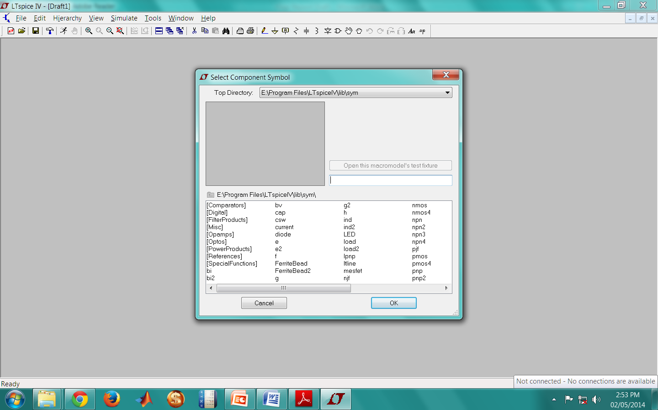

Fig 2.15 Component dialog box in LTspice IV

* Connecting the Circuit: All the components can now be connected using one of the following methods.
* clicking the "Draw Wire" button from the tool bar
* pressing F3"
* Selecting "Draw Wire" from the "Edit" menu.
* **Simulation**

The following checks must be carried out before simulating the circuit.

* Circuit is properly drawn and saved.
* There must be no floating parts on the circuit (i.e. unattached devices).
* All parts have the correct values.
* There are no extra wires.
* A ground is present in the circuit.
* Choosing a simulation: On choosing “Edit simulation Cmd” from the Simulate menu (Fig 2.16), the Edit Simulation Command window appears as shown in Fig 2.17

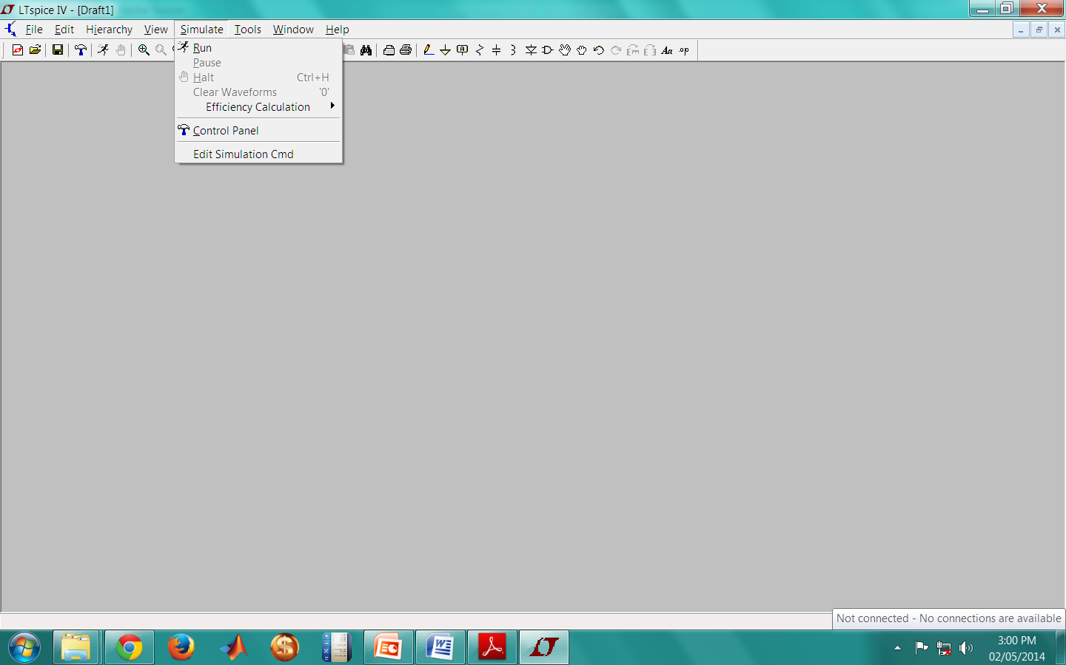

Fig 2.16 Choosing “Edit simulation Cmd” from the Simulate menu

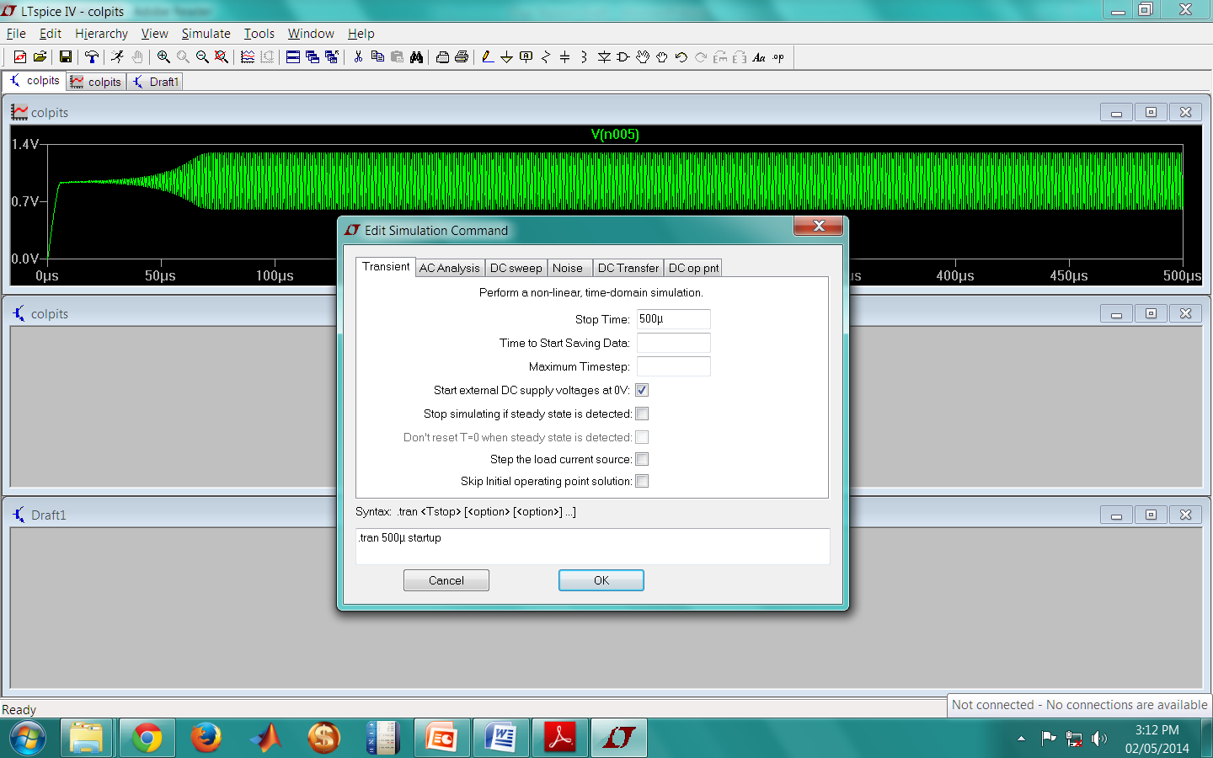

Fig 2.17 Edit simulation command window

The simulation can be run by enabling the type of analysis required and clicking the Simulate button on the tool bar or using the "Simulate/Run" command.

### 2.3.2 Arduino IDE

The Arduino integrated development environment (IDE) is a cross-platform application written in Java, and is derived from the IDE for the Processing programming language and the Wiring projects. It is designed to introduce programming to artists and other newcomers unfamiliar with software development. It includes a code editor with features such as syntax highlighting, brace matching, and automatic indentation, and is also capable of compiling and uploading programs to the board with a single click. A program or code written for Arduino is called a "sketch”.

Arduino programs are written in C or C++. The Arduino IDE comes with a software library called "Wiring" from the original Wiring project, which makes many common input/output operations much easier. Users only need define two functions to make a runnable cyclic executive program:

setup(): a function run once at the start of a program that can initialize settings

loop(): a function called repeatedly until the board powers off.

2.3.2.1 Using the Arduino integrated development environment (IDE) to program **ATmega 2560**

* The Arduino Mega will automatically draw power from either the USB connection to the computer or an external power supply.
* When powered up, the green power LED (labelled PWR) glows.
* On launching the Arduino IDE the following screen appears (Fig 2.18)

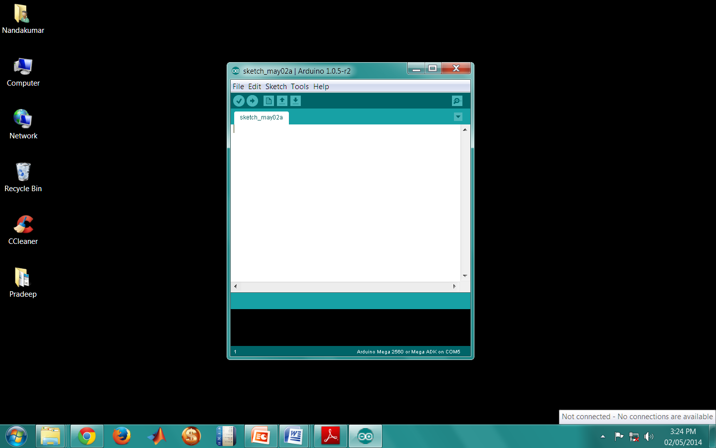

Fig 2.18 Arduino IDE

* A new sketch can now be opened by clicking “New” or an existing sketch can be opened by selecting “Open” from the “File” menu.

Fig 2.19 shows an opened sketch.

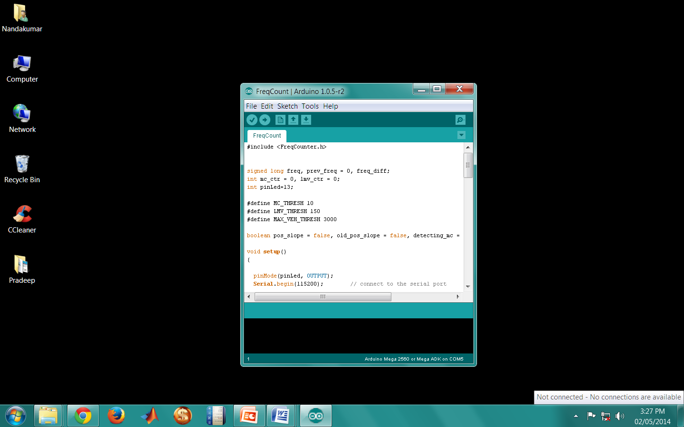

Fig 2.19 A sketch on the Arduino IDE

* Next the correct board is selected from “Board menu” under Tools as shown in Fig 2.20

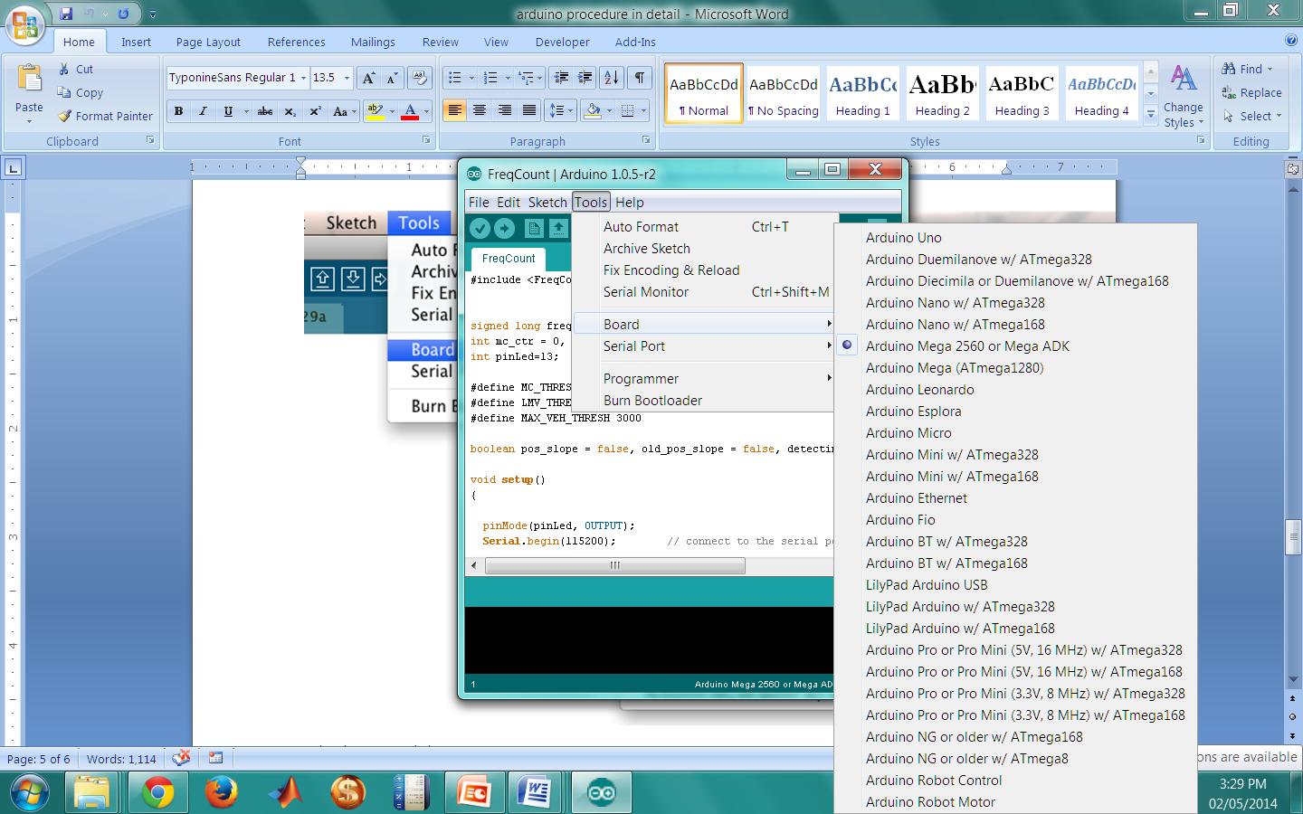

Fig 2.20 Selecting the correct board

* The correct serial port is now selected from the “Serial Port menu” under “Tools” menu.
* The program is then uploaded by clicking the "Upload" button in the environment.

The RX and TX LEDs on the board flash indicating that the program is being flashed on the microcontroller. If the upload is successful, the message "Done uploading." appears in the status bar.

### 2.3.3 Cygwin

Cygwin is a Unix-like environment and command-line interface for Microsoft Windows. Cygwin provides native integration of Windows-based applications, data, and other system resources with applications, software tools, and data of the Unix-like environment. Thus it is possible to launch Windows applications from the Cygwin environment, as well as to use Cygwin tools and applications within the Windows operating context.

Cygwin consists of two parts: a dynamic-link library (DLL) as an API compatibility layer providing a substantial part of the POSIX API functionality, and an extensive collection of software tools and applications that provide a Unix-like look and feel.

Cygwin was originally developed by Cygnus Solutions, which was later acquired by Red Hat. It is free and open source software, released under the GNU General Public License version 3. Today it is maintained by employees of Red Hat, NetApp and many other volunteers**.**

#### 

#### 2.3.3.1 Description

Cygwin consists of a library that implements the POSIX system call API in terms of Win32 system calls, a GNU development tool chain (including GCC and GDB) to allow software development, and a large number of application programs equivalent to those on Unix systems. Programmers have ported many Unix, GNU, BSD and Linux programs and packages to Cygwin, including the X Window System, K Desktop Environment 3, GNOME,[3] Apache, and TeX. Cygwin permits installing inetd, syslogd, sshd, Apache, and other daemons as standard Windows services, allowing Microsoft Windows systems to emulate Unix and Linux servers.

Cygwin programs are installed by running Cygwin's "setup" program, which downloads the necessary program and feature package files from repositories on the Internet. Setup can install, update, and remove programs and their source code packages. A complete installation will take in excess of 17 GB of hard disk space, but usable configurations may require as little as 1 or 2 GB.

### 2.3.5 iShell

The iShell programming, operating and analysis tool is the personal computer counterpart of the iSense operating and networking ﬁrmware. Besides a broad variety of functions for operating iSense wireless sensor networks that is already included, iShell can easily be extended through adding user Plugins. iShell offers its functionality to the user in a number of different views that group activities on separate tabulator windows.

First of all iShell can be used for both wired and wireless programming of the iSense devices Besides, the serial monitor view provides a text window for displaying messages transmitted from a connected device via a serial or USB connection. Other views for example

* send messages to the network via an attached sensor node,
* plot graphs of measured data captured in the network e.g. by the vehicle detection sensor or the accelerometer
* provide data export to Microsoft Excel
* display camera pictures captured by wireless sensors
* **Steps to program the core and vehicle detection modules using iShell:**
* The first step is to connect the iSense device to the PC. It must at least consist of an iSense Core Module and an iSense Gateway Module connected to the PC via a USB cable.
* On opening iShell the following window appears (Fig 2.21)
* The port to which the device is connected to is selected by clicking the “Serial” option from the “Preferences” menu and selecting the proper COM port from the drop down list as shown in Fig 2.22
* If the connection was successful, the logging pane at the bottom of the iShell window displays “New connection to Jennic device on COMX” as shown in Fig 2.23
* While the “Serial Monitor” plugin and the “Flash Loader” plugin are always active and cannot be closed, all other Plugins can be opened and closed on the “Plugins” tab. Plugins such as “Curve-Illustrator”, “Over the air programming” can be activated in this tab as shown in Fig 2.24



Fig 2.21 iShell



Fig 2.22 Selecting the proper port from the Preferences menu.



Fig 2.23 Notification indicating a successful connection



Fig 2.24 Activating Plugins from the “Plugins Tab”

* The “Flash Loader” plugin shown in Fig 2.25 provides functionality for flashing (i.e. programming) the connected device, analyzing the symbols in the program and reading and writing the device’s MAC address.



Fig 2.25 Flash Loader Plugin

* To flash a device, the *.bin file to be flashed is selected by clicking on the file select button in the “Flash Loader” section. It is necessary to ensure that the target chip version of the program and the chip version of the connected device match.
* The binary program is then flashed to the iSense device connected to the PC by choosing “Trigger programming mode”, clicking on “Start”, and waiting for program download to complete. The flash progress displays the progress of the flash in the status line of the iShell window.
* In the “MAC Address” section, the address for the connected devices can be read or written. However, both actions involve restarting the device.
* The “Serial monitor” plugin shown in Fig 2.26 provides two modes, which can be set in the “Mode” menu.
* The plain text mode displays all contents of text messages. Unknown characters are displayed as small boxes.
* Operating the serial monitor in the packet mode means that only debug- and fatal-messages are displayed in grey and with red background respectively.



Fig 2.26 Serial monitor Plugin

* Four buttons permit managing the serial monitor as well as the iSense sensor node attached to iShell.
* The leftmost button clears the window, the second pauses or restarts the output of messages to the text area, the third button resets the connected device, which means to restart the application on the device. The rightmost starts/stops the recording of incoming messages to a file. On click, a file selection dialog opens. After a file name is specified, messages are recorded to that file. The messages are recorded regardless of whether the text area output is paused or not. Clicking the button again stops the recording of messages.

### 2.3.6 Eclipse Indigo

Eclipse is an integrated development environment (IDE). It contains a base workspace and an extensible plug-in system for customizing the environment.

#### 2.3.6.1 Description

Written mostly in Java, Eclipse can be used to develop applications. By means of various plug-ins, Eclipse may also be used to develop applications in other programming languages: Ada, ABAP, C, C++, COBOL, Fortran, Haskell, JavaScript, Lasso, Natural, Perl, PHP, Python, R, Ruby (including Ruby on Rails framework), Scala, Clojure, Groovy, Scheme, and Erlang. It can also be used to develop packages for the software Mathematica. Development environments include the Eclipse Java development tools (JDT) for Java and Scala, Eclipse CDT for C/C++ and Eclipse PDT for PHP, among others.

The initial codebase originated from IBM VisualAge. The Eclipse software development kit (SDK), which includes the Java development tools, is meant for Java developers. Users can extend its abilities by installing plug-ins written for the Eclipse Platform, such as development toolkits for other programming languages, and can write and contribute their own plug-in modules.

Released under the terms of the Eclipse Public License, Eclipse SDK is free and open source software (although it is incompatible with the GNU General Public License).

* **Steps to compile a C++ program on Eclipse Indigo**
* The first step is to Install Eclipse.
* The perspective can be changed to C++ by selecting “Window” > “Open Perspective” > “Other…” from the menu bar, and choosing “C/C++ (default)”.
* Next the applications are imported into Eclipse by selecting “File” > “Import” > “General” > “Existing Projects into Workspace” as shown in Fig 2.27



Fig 2.27 Importing projects

* Next the folder of the application to be imported is selected. It must be ensured that the check box corresponding to “Copy to workspace” is NOT ticked (Refer Fig 2.28)



Fig 2.28 Importing existing projects into workspace

* On clicking “Finish”, the selected project is imported into the workspace.

“Projects:” list, this commonly indicates that a project with the same name has already been imported into Eclipse before (no two projects with the same name can be imported into Eclipse at the same time).

* The program can be built by clicking on (JN5148) in the “Make Targets” pane on the right as shown in Fig 2.29

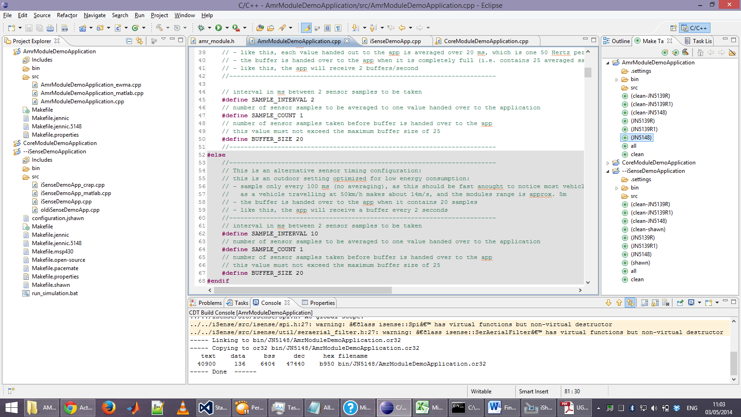

Fig 2.29 Building the program.

### 2.3.7 Microsoft Visual Studio 12.0

Microsoft Visual Studio is an integrated development environment (IDE) from Microsoft. It is used to develop computer programs for Microsoft Windows superfamily of operating systems, as well as web sites, web applications and web services. Visual Studio uses Microsoft software development platforms such as Windows API, Windows Forms, Windows Presentation Foundation, Windows Store and Microsoft Silverlight. It can produce both native code and managed code.

Visual Studio supports different programming languages and allows the code editor and debugger to support (to varying degrees) nearly any programming language, provided a language-specific service exists. Built-in languages include C, C++ and C++/CLI (via Visual C++), VB.NET (via Visual Basic .NET), C# (via Visual C#), and F# (as of Visual Studio 2010). Support for other languages such as M, Python, and Ruby among others is available via language services installed separately. It also supports XML/XSLT, HTML/XHTML, JavaScript and CSS. Individual language-specific versions of Visual Studio also exist which provide more limited language services to the user: Microsoft Visual Basic, Visual J#, Visual C#, and Visual C++.

* **Developing a GUI on Visual Studio 2013:**
* On opening Visual Studio the following window appears (Fig 2.30 )



Fig 2.30 Microsoft Visual Studio 2013

* A new C# project is started by choosing “New Project” under the “Start” menu and choosing Visual C# Windows Forms Application as shown in Fig 2.31

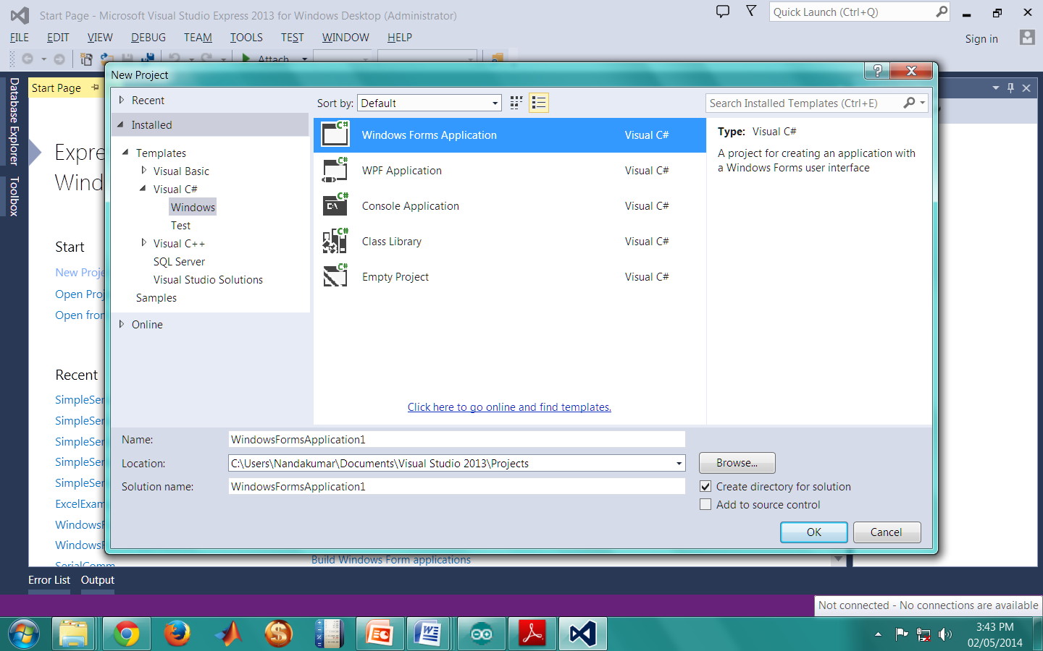

Fig 2.31 Creating a new C# project

* On completing the aforementioned steps, the following window appears (Fig 2.32).

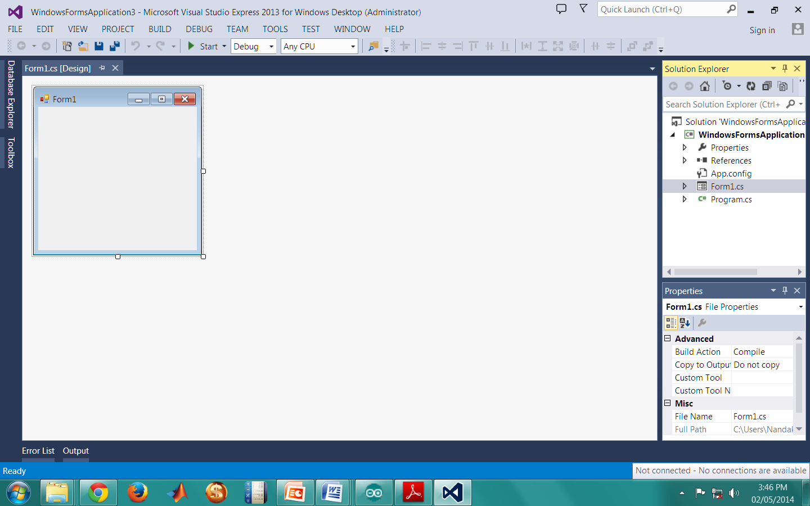

Fig 2.32 New Windows Form

* The GUI can now be designed using components from the Toolbox.
* Double clicking the GUI window opens the source code (Form1.cs)
* The code can be edited as per requirements.
* Finally the code is built and run by pressing F5.

**2.4 Design of Induction loop detector using Colpitt’s oscillator**

An oscillator has a small signal feedback amplifier with an open-loop gain equal to or slightly greater than one for oscillations to start but to continue oscillations the average loop gain must return to unity. In addition to these reactive components, an amplifying device such as an Operational Amplifier or Bipolar Transistor is required. Unlike an amplifier there is no external AC input required to cause the Oscillator to work as the DC supply energy is converted by the oscillator into AC energy at the required frequency.

A = 𝑉𝑜𝑢𝑡/𝑉𝑖𝑛

A= open loop voltage gain (i.e. without feedback)

Now let a fraction 𝛽 of the output voltage 𝑉𝑜𝑢𝑡 be supplied back to the input.

𝑉𝑖𝑛 = 𝑉𝑖𝑛+𝑉𝑓 = 𝑉𝑖𝑛+𝛽𝑉𝑜𝑢𝑡 ........... (2.5)

𝑉𝑖𝑛 = 𝑉𝑖𝑛 −𝑉𝑓 = 𝑉𝑖𝑛+𝛽𝑉𝑜𝑢𝑡 .......... (2.6)

Equation 2.5 is for positive feedback while equation 2.6 is for negative feedback

Where 𝑉𝑆 is the signal voltage and 𝑉𝑓 is the feedback voltage.

That is:

𝑉𝑖𝑛 = 𝑉𝑠±𝛽𝑉𝑜𝑢𝑡

Considering negative feedback

𝐴 𝑉𝑠−𝛽𝑉𝑜𝑢𝑡 = 𝑉𝑜𝑢𝑡

𝐴𝑉𝑠 = 𝑉𝑜𝑢𝑡 (1 + 𝐴𝛽)

The term Aβ is called the feedback factor whereas β is known as the feedback ratio and 1+βA is known as loop gain.

$\frac{Vout}{Vs }$ = $\frac{A}{1+Aβ}$ = 𝐴𝑓.......... (2.7)

where 𝐴𝑓 = the closed loop gain

Equation 2.7 is normally refer to as the closed loop voltage gain for negative feedback and for positive feedback it is given by,

𝐴𝑓 =

LC Oscillators are circuits that generate a continuous voltage output waveform at a required frequency with the values of the inductors, capacitors or resistors forming a frequency selective LC resonant tank circuit and feedback network. This feedback network is an attenuation network which has a gain of less than one (β<1) and starts oscillations when Aβ>1 which returns to unity (Aβ=1) once oscillations commence. The LC oscillator’s frequency is controlled using a tuned or resonant inductive/capacitive (L, C) circuit with the resulting output frequency being known as the Oscillation Frequency. By making the oscillators feedback a reactive network the phase angle of the feedback will vary as a function of frequency and this is called Phase-shift.

The frequency of the oscillator voltage depends upon the value of the inductance and capacitance in the LC tank circuit. We now know that for resonance to occur in the tank circuit, there must be a frequency point were the value of XC, the capacitive reactance is the same as the value of XL, the inductive reactance (XL, XC) and which will therefore cancel out each other out leaving Only the D.C resistance in the circuit to oppose the flow of current. If we now place the curve for inductive reactance of the inductor on top of the curve for capacitive reactance of the capacitor so that both curves are on the same frequency axes, the point of intersection will give us the resonance frequency point, (fr or ωr).

An induction loop detector provides a low cost method for detection of vehicles. The system consists of a loop of wire (typically 4 or 5 turns) buried approximately 20 mm below the road surface. The ends of the loop are returned to the vehicle detector usually housed some distance away in the controller cabinet. The output of the oscillator is converted into a square wave using a comparator and fed to the input capture pin of the microcontroller. The circuit diagram of the oscillator along with the comparator is shown in Fig 2.33



Fig 2.33 Circuit diagram of Colpitt’s oscillator and comparator

The typical output waveforms of the oscillator and the comparator are shown in Fig 2.34

When the system is turned on, a high frequency counter sourced by a crystal oscillator is started on the microcontroller. Whenever a rising edge occurs on the input capture pin, the counter value is recorded. The difference in consecutive captured counter values can be used to determine the time period and frequency of the input signal.

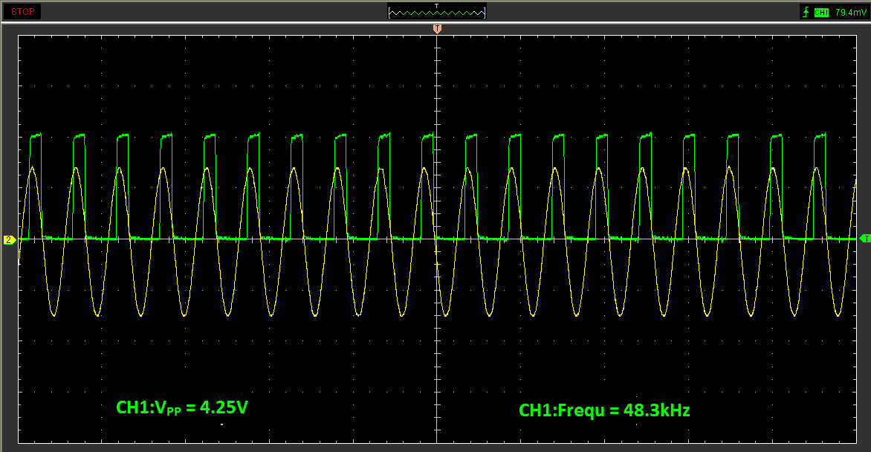

Fig 2.34 Output waveforms of the oscillator (in yellow) and the comparator (in green)

A decrease in the inductance of the loop occurs when a vehicle is positioned over it. This decrease causes a corresponding increase in the output frequency of the LC oscillator. This increase is sensed by the microcontroller that outputs a signal to the computer to indicate the presence of a vehicle. The amount of change in the inductance and hence the frequency is used to classify the vehicles as two wheelers and four wheelers.

The following data (Table 2.1) was used to arrive at the no. of turns of the induction loop.

|  |  |  |  |
| --- | --- | --- | --- |
| Dimensions | No. of turns | Center frequency | Frequency drift |
| 1.5ft x 1.5ft | 10 | 48.3 kHz | 500 Hz |
| 6ft x 6ft | 2 | 80 kHz (Unstable) | Unreliable |
| 6ft x 6ft | 3 | 51 kHz | 300 Hz |
| 6ft x 6ft | 4 | 41 kHz | 1000 Hz |
| 6ft x 6ft | 5 | 32.5 kHz | 750 Hz |

Table 2.1 Data used to arrive at the no. of turns of the induction loop

The dimension of 6ft x 6ft was chosen since the average width of a passenger car and the average length of a two wheeler is 6ft. This is important since maximum frequency drift is observed when the dimension of the metallic object is comparable to the dimension of the induction loop.

A snapshot of the induction loop and the detector components are shown in Fig 2.35 and Fig 2.36 respectively. Fig 2.37 shows the entire induction loop system.

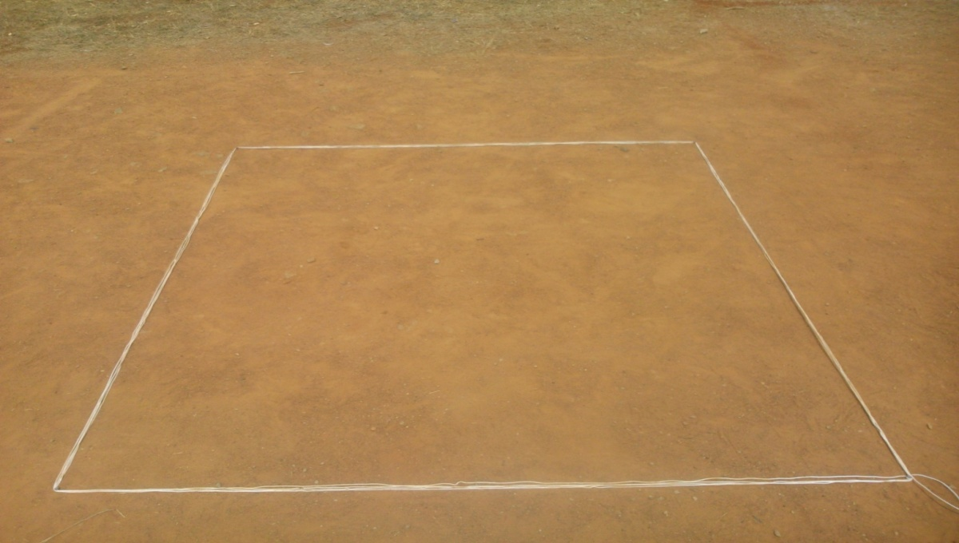

Fig 2.35 Snapshot of the Induction Loop

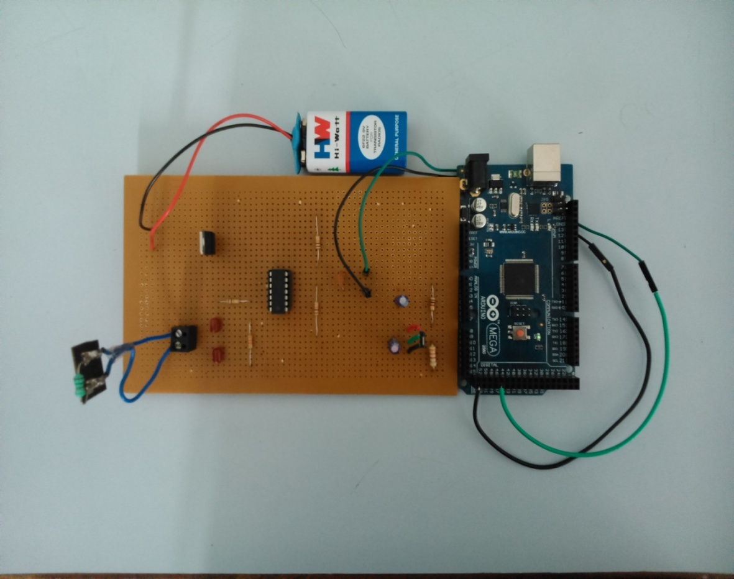

Fig 2.36 Snapshot of Induction Loop detector components

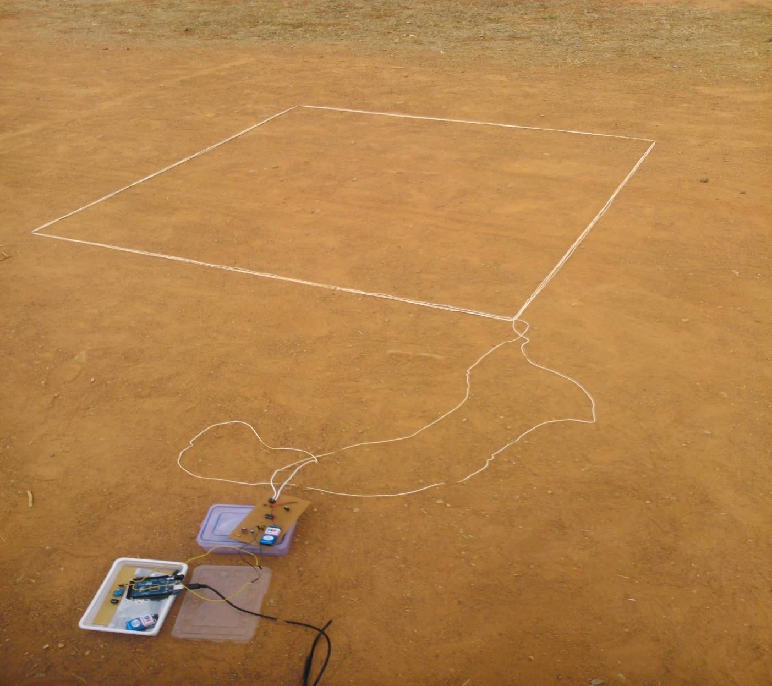

Fig 2.37 Snapshot of the induction loop system

A snapshot of the GUI used to display the traffic parameters acquired by the induction loop is shown in Fig 2.38

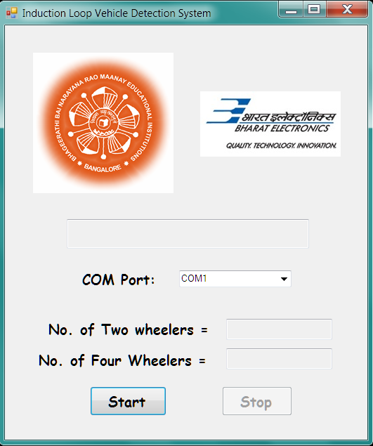

Fig 2.38 GUI for displaying traffic parameters acquired by the induction loop system

Table 2.2 shows the format of the database that stores the data about the count and class of vehicles acquired by the Induction Loop system.

|  |  |  |  |
| --- | --- | --- | --- |
| Date | Two wheeler Count | Four Wheeler count | Total count |
| 30/04/2014 | 9 | 9 | 18 |
| 01/05/2014 | 5 | 6 | 11 |
| 02/05/2014 | 3 | 2 | 5 |
|  |  |  |  |
|  |  |  |  |
|  |  |  |  |

Table 2.2 Database format for induction loop detector system

## 2.5 Design of AMR sensor vehicle detection system

The AMR sensor vehicle detection system consists of a core module and a vehicle detection module containing magnetic sensors. The iSense Core Module is based on a Jennic JN5148 wireless microcontroller, a chip that combines the controller and the wireless communication transceiver in a single housing. The controller provides 32 bit RISC computation, runs at a software-scalable frequency from 4 to 32 MHz and comprises 128kbytes of memory that are shared by program code and data. The radio part complies with the IEEE 802.15.4 standard. It achieves a data rate of 250kBit/s, provides hardware AES encryption and is ZigBee-ready.

A snapshot of the iSense Core Module is shown in Fig 2.39

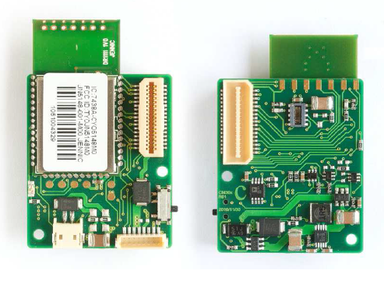

Fig 2.39 iSense Core Module

The iSense Vehicle Detection Module (VDM10) is intended for detection of dynamic magnetic fields. The VDM10 is based on the two-axis anisotropic magneto-resistive (AMR) sensor Phillips KMZ52. The module also provides a de-gaussing circuitry and static magnetic field offset compensation. All three are controlled via I2C commands.

A snapshot of the vehicle detection module is shown in Fig 2.40

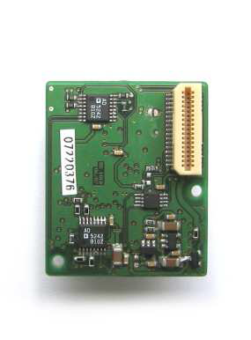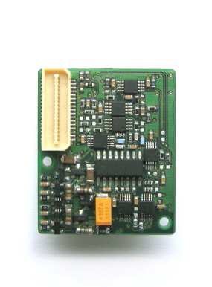

Fig 2.40 Snapshot of the Vehicle detection module

The typical output waveform of an AMR sensor when a vehicle passes over it is as shown in Fig 2.41

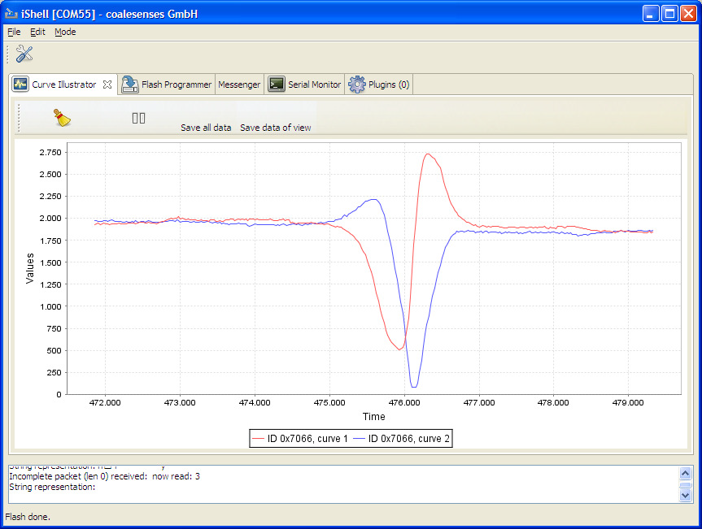

Fig 2.41 Typical output waveform of the AMR sensor. The two curves represent the output of the sensor in the two axes.

An AMR sensor vehicle detection system provides a low power solution for detection of vehicles. The system consists of two sensor modules which act as slaves and a core module which acts as a master. The slave modules communicate wirelessly with the master module via the ZigBee protocol. The master module is connected to a computer using a serial cable and communicates with it via UART. The computer is used to store the database and display it using a GUI.

The sensors on the slave modules detect the change in the ambient magnetic field. Initially they are calibrated to account for the magnetic field of the ambient environment and the default magnetic field generated by the earth. When a ferromagnetic material (commonly found in vehicles) passes over the sensor it disturbs the magnetic field around it. This change in magnetic field is detected by the sensor. It is observed that the output of the sensor peaks when a vehicle passes over it. These peaks are used to detect the presence of vehicles.

An EWMA (Exponentially weighted moving average) filter is used to eliminate the noise in the sensor output and obtain a smooth waveform. An algorithm running on the slave module that monitors the slope of the waveform when the sensor outputs cross a threshold is used to detect that a vehicle has passed over it. The absence of the slope detection algorithm can cause multiple detections for the same vehicle since the waveform stays over the threshold for several sampling instants. When a vehicle is detected, a time stamp indicating the time at which the vehicle crossed over the sensor is sent to the master module.

The slave modules are buried along the length of the road with a distance of two meters between them. Thus the time stamps sent by the two slave modules differ by a small value Δt as the vehicle passes over the two sensors one after the other. This difference is used to find the speed of the vehicle using the formula

S = D/Δt

Where

S is the speed,

D is the distance between the two sensors

Δt is the time difference.

The sensor modules contain an internal clock which is used to keep track of time for which the slave modules are on. The internal clock is started at the moment the sensor modules are turned on. Since both the sensor modules cannot be turned on simultaneously, an initial time difference exists between the clocks of the two sensor modules. This time difference adds to Δt leading to an error in the speed calculation. To eliminate this, the initial time difference is subtracted from Δt. This is achieved using a synchronization algorithm running on the master and slave modules.

When a vehicle is detected, the time difference Δt is calculated by the master module and sent to the PC via UART where the speed is computed and the count and speed are stored in the database.

A snapshot of the experimental setup used to calculate speed in case of AMR vehicle detection system is shown in Fig 2.42



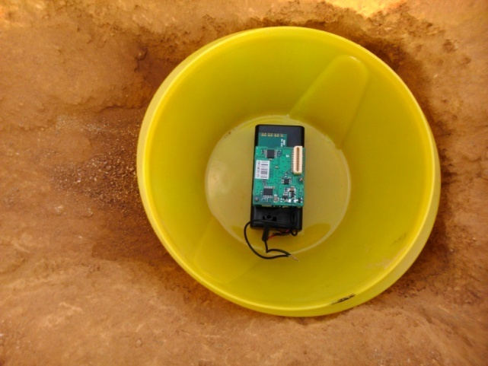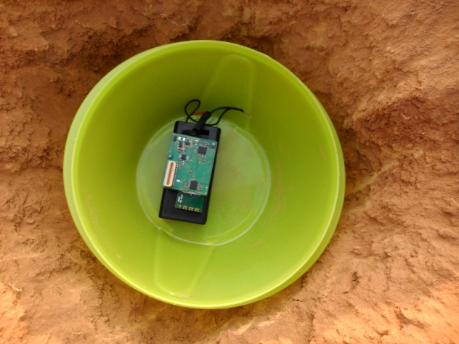

Fig 2.42 Experimental setup used to calculate speed in case of AMR vehicle detection system

Fig 2.43 shows a snapshot of the GUI used to display the traffic parameters acquired by the AMR vehicle detection system.

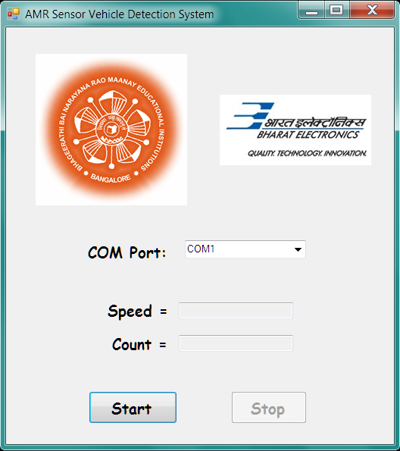

Fig 2.43 GUI to display the traffic parameters acquired by the AMR vehicle detection system

Table 2.3 shows the format of the database that stores the data about the count and speed of vehicles acquired by the AMR vehicle detection system.

|  |  |  |
| --- | --- | --- |
| Date | Vehicle count | Average speed (kmph) |
| 03/05/2014 | 8 | 22.92 |
| 04/05/2014 | 8 | 24.20 |
|  |  |  |
|  |  |  |
|  |  |  |
|  |  |  |

Table 2.3 Database format for AMR sensor vehicle detection system

# III. RESULTS

## 3.1 Induction loop vehicle detection system

* **Frequency drifts**

The induction loop system was tested to determine the frequency drifts for two wheelers and four wheelers at different speeds. Ten trials were carried out at each speed ranging from 10 to 40 for each type of vehicle. The results obtained are tabulated below (Table 3.1 and Table 3.2).

* **Two wheelers**

|  |  |  |
| --- | --- | --- |
| **Speed (kmph)** | **Frequency drift (Hz)** | **Avg. frequency drift** |
| **10** | 55 | **55.3** |
| 38 |
| 52 |
| 56 |
| 52 |
| 64 |
| 50 |
| 64 |
| 72 |
| 50 |
| **20** | 50 | **48.2** |
| 60 |
| 54 |
| 52 |
| 42 |
| 30 |
| 54 |
| 36 |
| 36 |
| 68 |
| **30** | 48 | **39.4** |
| 32 |
| 46 |
| 50 |
| 24 |
| 42 |
| 50 |
| 54 |
| 22 |
| 26 |
| **40** | 24 | **34** |
| 44 |
| 16 |
| 36 |
| 50 |
| 36 |
| 28 |
| 26 |
| 45 |
| 35 |

Table 3.1 Frequency drift values for different speeds in case of two wheelers

* **Four wheelers**

|  |  |  |
| --- | --- | --- |
| **Speed (kmph)** | **Frequency drift (Hz)** | **Avg. frequency drift** |
| **10** | 1100 | **1010.8** |
| 896 |
| 880 |
| 962 |
| 872 |
| 1106 |
| 1136 |
| 990 |
| 1068 |
| 1098 |
| **20** | 958 | **1006.2** |
| 1262 |
| 764 |
| 806 |
| 1406 |
| 900 |
| 856 |
| 1010 |
| 960 |
| 1140 |
| **30** | 1200 | **1000.2** |
| 924 |
| 986 |
| 1212 |
| 688 |
| 952 |
| 982 |
| 872 |
| 940 |
| 1246 |
| **40** | 916 | **937.8** |
| 746 |
| 1056 |
| 1014 |
| 936 |
| 960 |
| 1020 |
| 899 |
| 943 |
| 888 |

Table 3.2 Frequency drift values for different speeds in case of four wheelers

Thus the frequency drift is found to decrease with speed in case of both two wheelers and four wheelers. This is due to the fact that the vehicle stays within the loop for a shorter duration of time as the speed increases. Thus the eddy currents induced in the loop are lower resulting in a smaller decrease in inductance and hence a smaller increase in frequency.

* **Accuracy of count**

No. of trials = 50

No. of times a vehicle went undetected or detected more than once = 4

**Accuracy = 92%**

* **Accuracy of classification**

No. of trials = 50

No. of times a two wheeler was detected as a four wheeler or vice versa = 5

**Accuracy = 90%**

## 

## 3.2 AMR sensor vehicle detection system

* **Accuracy of detected speed**

The AMR sensor vehicle detection system was tested to determine the accuracy of the detected speed for two wheelers and four wheelers at different speeds. Eight trials were carried out for each type of vehicle. The results obtained are tabulated below (Table 3.3).

|  |  |  |  |
| --- | --- | --- | --- |
| Type of vehicle | Actual speed (kmph) | Detected speed (kmph) | Error (in %) |
| Two wheelers | 10 | 8.98 | 10.2 |
| 10 | 7.64 | 23.6 |
| 20 | 18.00 | 10.0 |
| 20 | 21.56 | 7.8 |
| 30 | 26.54 | 11.5 |
| 30 | 28.87 | 3.8 |
| 40 | 35.64 | 10.9 |
| 40 | 36.11 | 9.7 |
| Four wheelers | 10 | 10.58 | 5.8 |
| 10 | 12.00 | 20 |
| 20 | 18.23 | 8.8 |
| 20 | 20.57 | 2.8 |
| 30 | 27.91 | 7.0 |
| 30 | 30.35 | 1.2 |
| 40 | 37.22 | 6.9 |
| 40 | 36.78 | 8.1 |

Table 3.3 Accuracy of the detected speed for two wheelers and four wheelers at different speeds

The actual error values may be lower than the mentioned values since the actual speed was observed on analog speedometers.

* **Accuracy of count**

No. of trials = 25

No. of times a vehicle went undetected or detected more than once = 1

**Accuracy = 96%**

# IV. CONCLUSION

* One of the advantages of Induction loop detector system over AMR sensor vehicle detection system is that the initial installation costs are much lower. They can also detect stopped vehicles.
* However, significant and reliable change in magnetic field occurs only when the vehicle is completely inside the loop, as against the AMR sensors which are more sensitive to the presence of magnetic materials.
* Magnetic sensors are more economical compared to inductive loops as they are easy to reinstall and maintenance costs are low.
* Magnetic sensors are smaller in size compared to inductive loops which require a minimum area of around 36 sq. ft.
* Magnetic sensors have proven to be more immune to noise and stable compared to frequency drifts occurring in the induction loop system due to environmental changes.
* Devices embedded in asphalt often get damaged as a result of pressure exerted on the ground by heavy vehicles passing. Small sensors have therefore an advantage over those like large inductive loops, as their re-installation is associated with lower costs.
* The sensing and measurement architecture of magnetic sensors uses a minimal level of energy and uses state-of-the-art low-power sensing, amplification, and communication technologies.
* Thus magnetic sensor systems are more efficient and reliable than induction loops.

# V. FUTURE ENHANCEMENTS

* **Induction Loop vehicle detection system**
* Two loops can be used to determine the speed of the vehicles.
* Methods for solving the problem of detection of vehicles moving parallel to each other can be implemented.
* **AMR vehicle detection system**
* Sensors with higher sampling rate can be used to classify vehicles based on their magnetic signature.

Auxiliary sensors such as video processing systems and infrared sensors can be used in conjunction with the induction loop and AMR sensor systems to eliminate false counts and increase the accuracy of the traffic parameters acquired.

# VI. REFERENCES

[1] Ravneet Bajwa, Ram Rajagopal, Pravin Varaiya and Robert Kavaler. In-Pavement Wireless Sensor Network for Vehicle Classification.

[2] Sing Yiu Cheung, Sinem Coleri Ergen and Pravin Varaiya. Traffic Surveillance with Wireless Magnetic Sensors.

[3] Farshad Ahdi, Mehdi Kalantari Khandani, Masoud Hamedi, Ali Haghani.

Traffic data collection and anonymous vehicle detection using wireless sensor networks.

[4] Traffic Detector Handbook: Third Edition—Volume I. Publication No. FHWA-HRT-06-108.

[5] D. Cebon. Handbook of Vehicle-Road Interaction.

Swets and Zeitlinger Publishers, 1999.

[6] Sun C. (2004). An investigation in the use of inductive loop signatures for vehicle classification. California PATH Research Report UCB-ITS-PRR-2002-4.

[7] Zhang, X., Y. Wang, N.L. Nihan (2004). Monitoring a freeway network in real-time using single-loop detectors: System design and implementation, 83rd TRB Annual Meeting, Washington, D.C.

[8] Ding, J (2003). Vehicle detection by sensor network nodes. MS thesis, Department of Electrical Engineering and Computer Science, University of California, Berkeley, CA.

[9] Oh, S., S.G. Ritchie, C (2002). Oh. Real time traffic measurement from single loop inductive signatures, 81st TRB Annual Meeting, Washington, D.C.

[11] G.S.M. Galandanci & K.O. Ewansiha. Design and simulation of a 20 khz to 50 khz variable frequency oscillator (vfo). [www.arpapress.com/](http://www.arpapress.com/) Volumes/ Vol16Issue1/ IJRRAS_16_1_04.pdf

[12] Gordon, R.L., R.A. Reiss, H. Haenel, E.R. Case, R.L. French, A. Mohaddes, and R.

Wolcott; Traffic Control Systems Handbook, FHWA-SA-95-032, Federal Highway

Administration, U.S. Department of Transportation, Washington, D.C., Feb. 1996

[13] Seri Oh, Stephen G. Ritchie, and Cheol Oh. Real Time Traffic Measurement From

Single Loop Inductive Signatures, presented for 81st Annual Meeting of the Transportation

Research board, Washington D.C., January 2002.

[14] Chao Chen, Jaimyoung Kwon, John Rice, Alexander Skabardonis and Pravin

Varaiya. Detecting Errors and Imputing Missing Data for Single Loop Surveillance

Systems, Presented in the 82nd Transportation Research Board Annual Meeting,

Washington D.C., January 2003.

[15] Luz Elena Y. Mimbela and Lawrence A. Klein. A Summary of Vehicle Detection

and Surveillance Technologies used in Intelligent Transportation Systems, the Vehicle

Detector Clearinghouse, New Mexico State University, Fall 2000.

[16] Sun, C., S.G. Ritchie, and K. Tsai. Algorithm Development for Derivation of

Section-Related Measures of Traffic System Performance using Inductive Loop Detectors.

In Transportation Research Record 1643, TRB, National Research Council, Washington,

D.C., 1998, pp. 171-180.

[17] Marcin Bugdol, Zuzanna Segiet, Michal Krecichwost, Pawel KASPEREK,Vehicle Detection System Using Magnetic Sensors,Transport Problems 2014 Volume 9 Issue 1

[18] Ripka, P. Magnetic Sensors and Magnetometers. Norwood: Artech House. 2001.

[19] Texas Transportation Institute. Alternative Vehicle Detection Technologies for Traffic Signal

Systems: Technical Report. Austin. 2008.

[20] Tumański, S. Thin Film Magnetoresistive Sensors. London: IOP Publ. 2001.

**APPENDIX**

**INTRODUCTION**

**DESIGN**

**RESULTS**

**CONCLUSION**

**FUTURE ENHANCEMENTS**

**REFERENCES**